Create a generative AI chat app

- In a web browser, open the Foundry portal at https://ai.azure.com and sign in using your Azure credentials
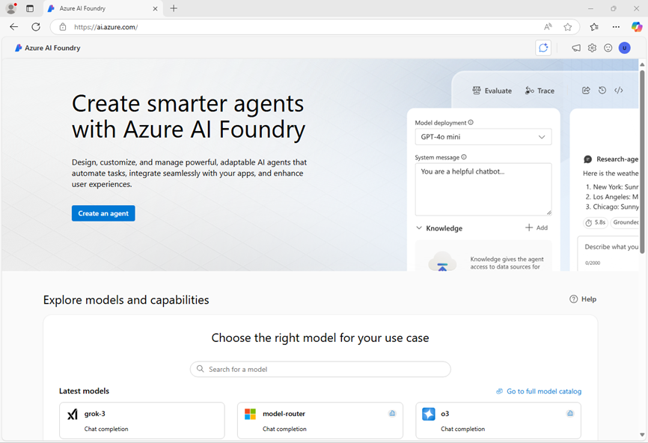
- In the home page, in the Explore models and capabilities section, search for the gpt-4o model; which we’ll use in our project. Select the gpt-4o model .
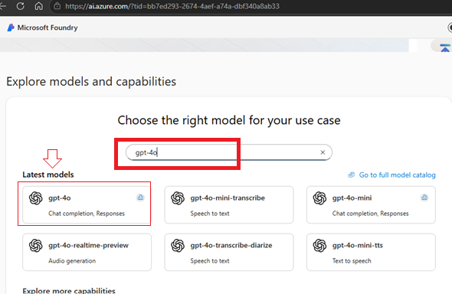
- At the top of the page for the model, select Use this model.

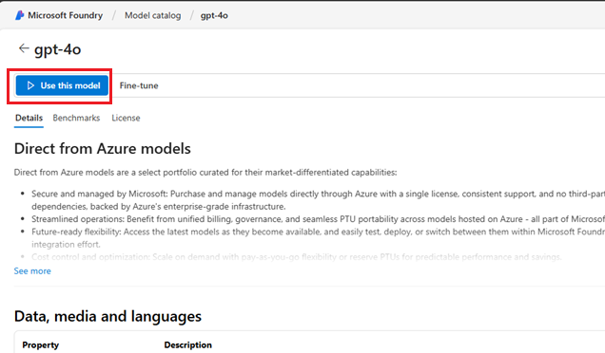

- Click drop down and select create a new project
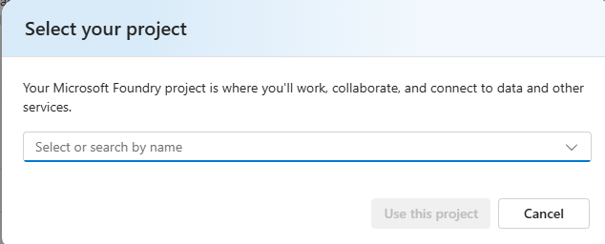

- Enter a valid name for your project and click Advance Options
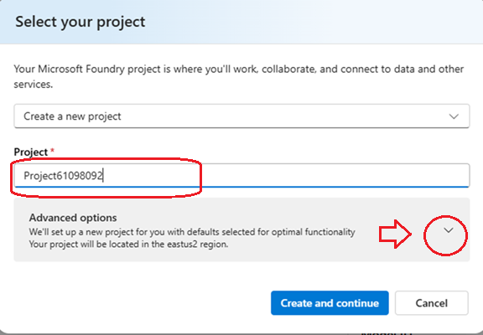

- Specify the following settings for your project:
  - Foundry resource: A valid name for your Foundry resource
  - Subscription: Your Azure subscription
  - Resource group: Create or select a resource group
  - Region: Select any AI Foundry recommended*

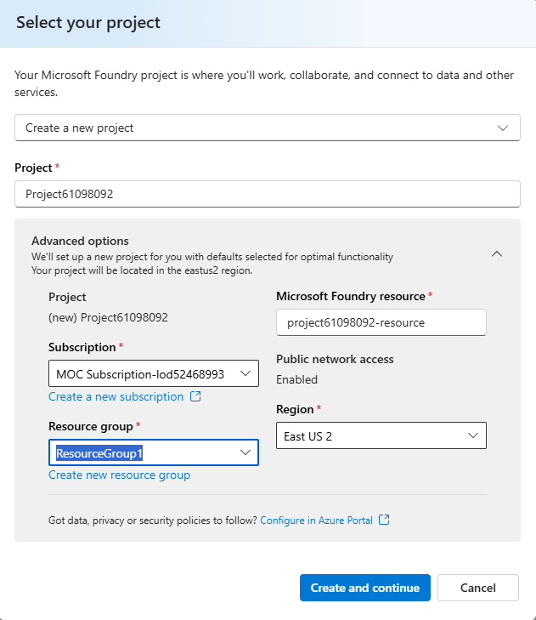
- Select Create and continue and wait for your project, including the gpt-4o model deployment you selected, to be created.
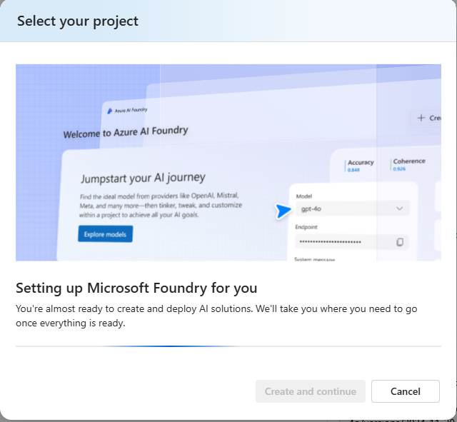

- Depending on your available quota for gpt-4o models you might receive a additional prompt to deploy the model to a resource in a different region.

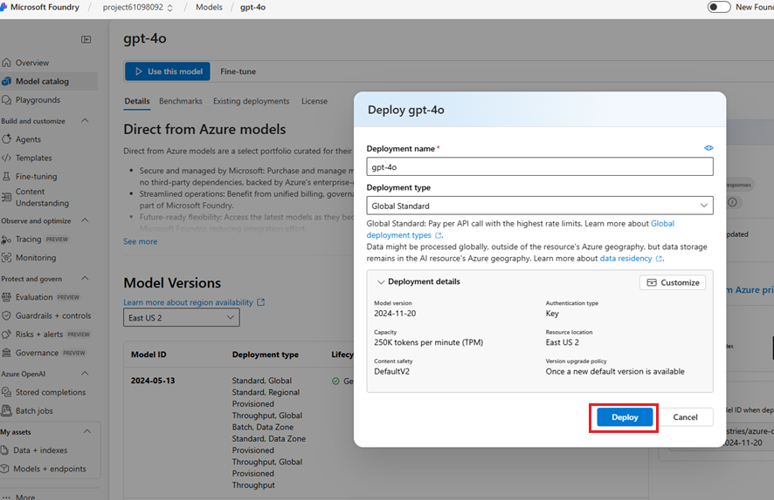

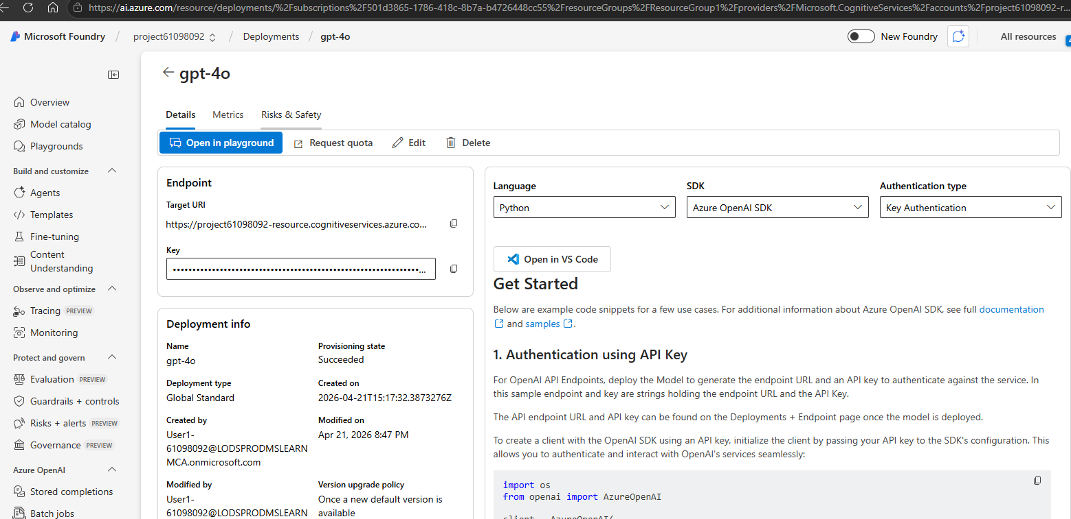

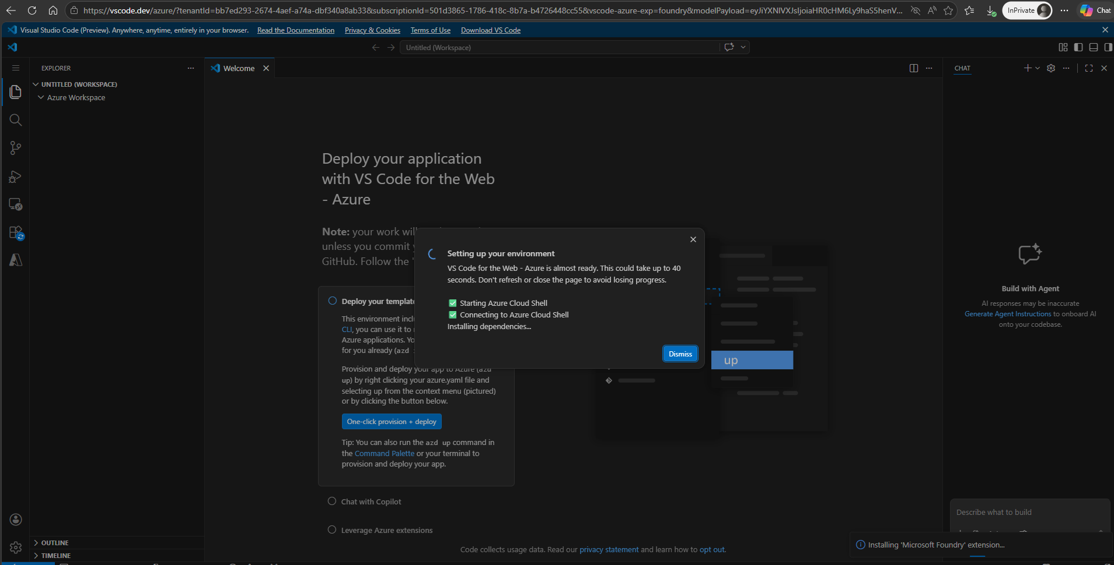

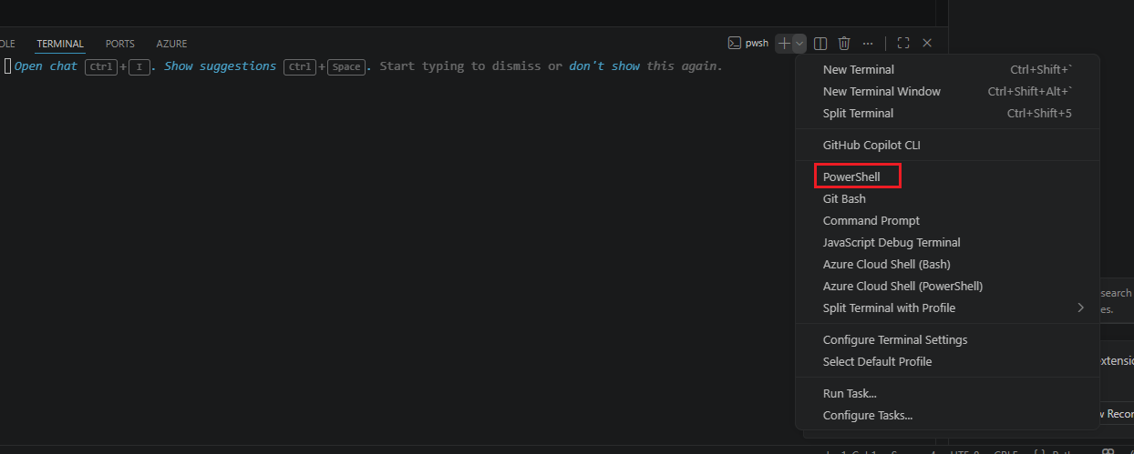
# Create a Python virtual environment
py -m venv labenv
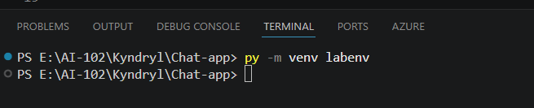

Notice new folder and files

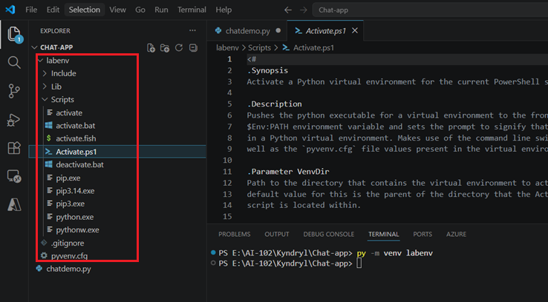
# Activate the virtual environment
.\labenv\Scripts\Activate.ps1

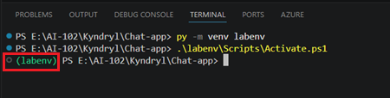

Step 4: Install Required Package
pip install openai

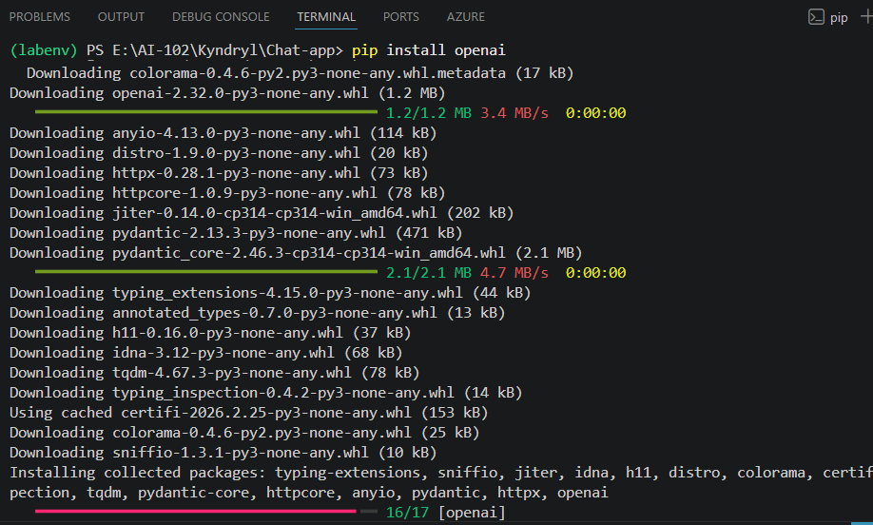

Install dotenv:
pip install python-dotenv

pip install flask
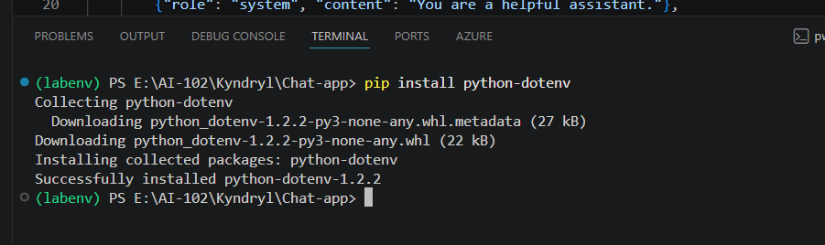

Step 5: Add Your Azure Details

Create file: .env

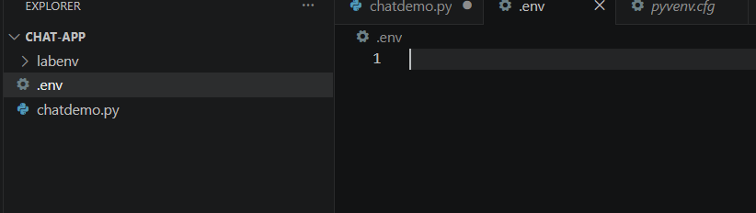

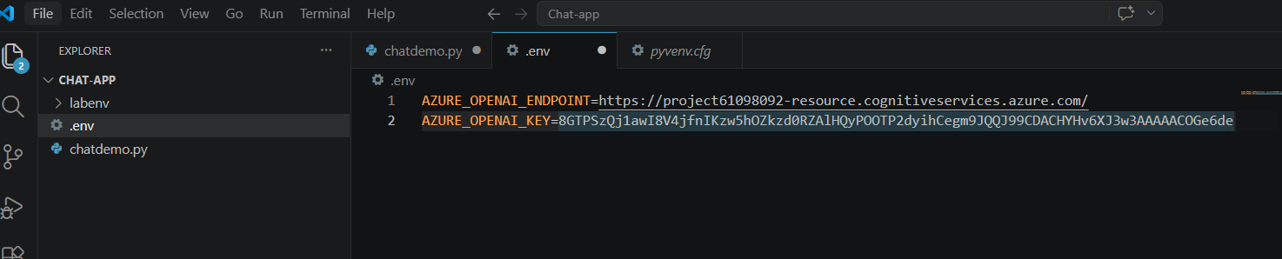
Step 6: Paste Working Code (Step 3: Backend Code)
from flask import Flask, render_template, request, jsonify
import os
from openai import AzureOpenAI
from dotenv import load_dotenv

load_dotenv()

app = Flask(__name__)

client = AzureOpenAI(
api_version="2024-12-01-preview",
azure_endpoint=os.getenv("AZURE_OPENAI_ENDPOINT"),
api_key=os.getenv("AZURE_OPENAI_KEY")
)

messages = [{"role": "system", "content": "You are a helpful assistant."}]

@app.route("/")
def home():
return render_template("index.html")

@app.route("/chat", methods=["POST"])
def chat():
user_input = request.json["message"]

messages.append({"role": "user", "content": user_input})

response = client.chat.completions.create(
model="gpt-4o",
messages=messages
)

reply = response.choices[0].message.content
messages.append({"role": "assistant", "content": reply})

return jsonify({"reply": reply})

if __name__ == "__main__":
app.run(debug=True)

Step 4: Create UI
Create folder: templates and Inside it → index.html
<!DOCTYPE html>

<html lang="en">
<head>
<meta charset="UTF-8">
<title>FunGPT Premium</title>

<style>
body {
margin: 0;
font-family: "Segoe UI", sans-serif;
background: linear-gradient(135deg, #2b2d42, #1a1c2c);
color: white;
}

/* Header */
.header {
text-align: center;
padding: 18px;
font-size: 22px;
font-weight: bold;
background: rgba(0,0,0,0.4);
backdrop-filter: blur(10px);
}

/* Chat container */
#chat {
max-width: 850px;
margin: 20px auto;
height: 420px;
overflow-y: auto;
padding: 20px;
border-radius: 15px;
background: rgba(255,255,255,0.05);
backdrop-filter: blur(12px);
}

/* Messages */
.message {
display: flex;
align-items: flex-end;
margin: 12px 0;
}

.message.user {
justify-content: flex-end;
}

.bubble {
padding: 12px 16px;
border-radius: 15px;
max-width: 70%;
line-height: 1.4;
}

.user .bubble {
background: #10a37f;
}

.ai .bubble {
background: #2d2f3a;
}

/* Avatar */
.avatar {
width: 35px;
height: 35px;
border-radius: 50%;
margin: 0 8px;
}

/* Input */
.input-area {
max-width: 850px;
margin: auto;
display: flex;
gap: 10px;
padding: 10px;
}

textarea {
flex: 1;
height: 70px;
border-radius: 10px;
border: none;
padding: 12px;
font-size: 14px;
resize: none;
}

/* Buttons */
button {
background: linear-gradient(135deg, #10a37f, #0d8f6a);
border: none;
color: white;
padding: 10px 18px;
border-radius: 10px;
cursor: pointer;
}

button:hover {
opacity: 0.9;
}

/* Reset */
.controls {
max-width: 850px;
margin: auto;
text-align: right;
padding: 10px;
}

/* Welcome */
.welcome {
text-align: center;
margin-top: 40px;
opacity: 0.85;
}

.suggestions {
margin-top: 15px;
}

.suggestions div {
background: rgba(255,255,255,0.1);
margin: 6px;
padding: 8px;
border-radius: 8px;
cursor: pointer;
display: inline-block;
}

.suggestions div:hover {
background: rgba(255,255,255,0.2);
}

/* Typing */
.typing {
font-style: italic;
opacity: 0.7;
}
</style>

</head>

<body>

<div class="header">
🤖 FunGPT Premium — Ask anything
</div>

<div id="chat">
<div id="welcome" class="welcome">
<h2>Welcome 👋</h2>
<p>How can I help you today?</p>

```
<div class="suggestions">
<div onclick="quickAsk('Explain Azure AI')">Explain Azure AI</div>
<div onclick="quickAsk('Plan a Europe trip')">Plan a trip</div>
<div onclick="quickAsk('Write Python code')">Write code</div>
</div>
</div>
```

</div>

<div class="controls">
<button onclick="resetChat()">🔄 Reset</button>
</div>

<div class="input-area">
<textarea id="msg" placeholder="Type your message..."></textarea>
<button onclick="send()">Send</button>
</div>

<script>
async function send(customMsg=null) {
let msgBox = document.getElementById("msg");
let msg = customMsg || msgBox.value.trim();

if (!msg) return;

let chat = document.getElementById("chat");

document.getElementById("welcome")?.remove();

// User message
chat.innerHTML += `
<div class="message user">
<div class="bubble">${msg}</div>
<img class="avatar" src="https://i.pravatar.cc/40?img=3">
</div>`;

msgBox.value = "";
chat.scrollTop = chat.scrollHeight;

// Typing indicator
chat.innerHTML += `<div id="typing" class="typing">FunGPT is typing...</div>`;

let response = await fetch("/chat", {
method: "POST",
headers: {"Content-Type": "application/json"},
body: JSON.stringify({message: msg})
});

let data = await response.json();

document.getElementById("typing")?.remove();

// AI response
chat.innerHTML += `
<div class="message ai">
<img class="avatar" src="https://cdn-icons-png.flaticon.com/512/4712/4712027.png">
<div class="bubble">${data.reply}</div>
</div>`;

chat.scrollTop = chat.scrollHeight;
}

// Enter send
document.getElementById("msg").addEventListener("keydown", function(e) {
if (e.key === "Enter" && !e.shiftKey) {
e.preventDefault();
send();
}
});

// Quick suggestions
function quickAsk(text) {
send(text);
}

// Reset
async function resetChat() {
document.getElementById("chat").innerHTML = `
<div id="welcome" class="welcome">
<h2>Welcome 👋</h2>
<p>How can I help you today?</p>
</div>`;
await fetch("/reset", {method:"POST"});
}
</script>

</body>
</html>

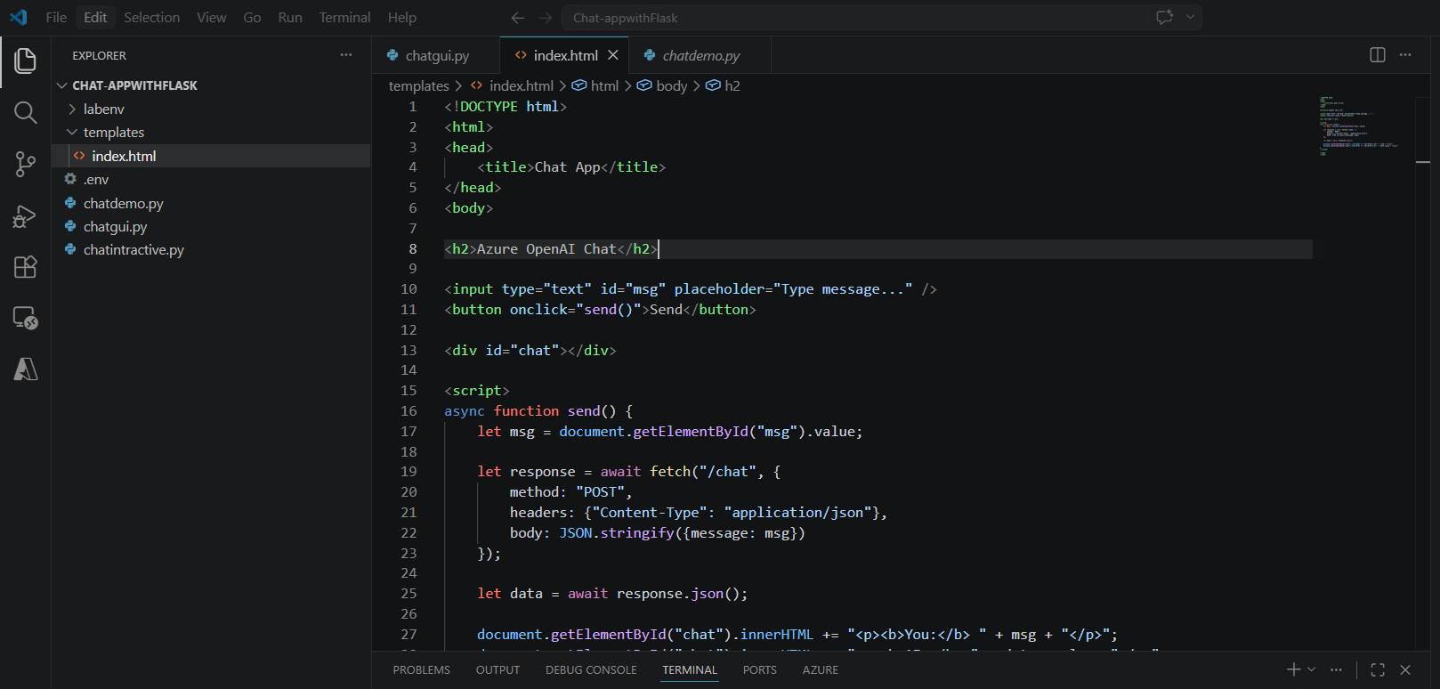
py .\chatgui.py

